Rotunda
# Source: AI Source: Provided by: [Data Path: Persons Table -> ID Column: 1, Name_En Column: Motasem Essam] -> From: [ChatGPT] on [7/25/2026]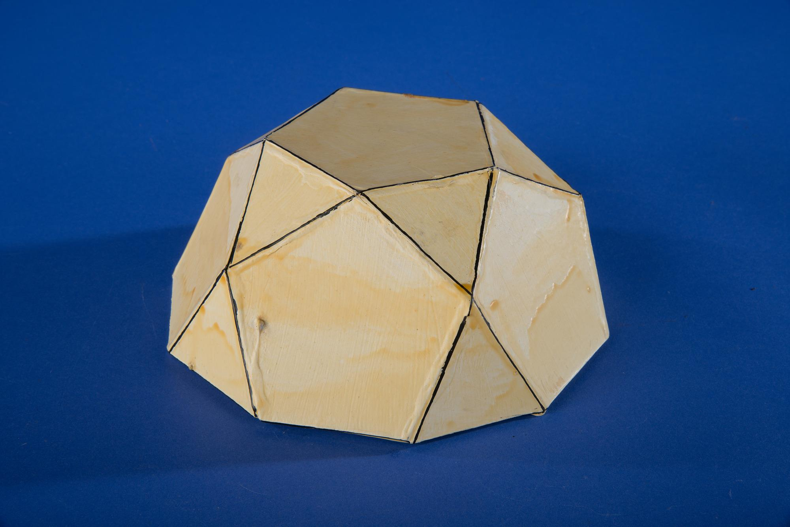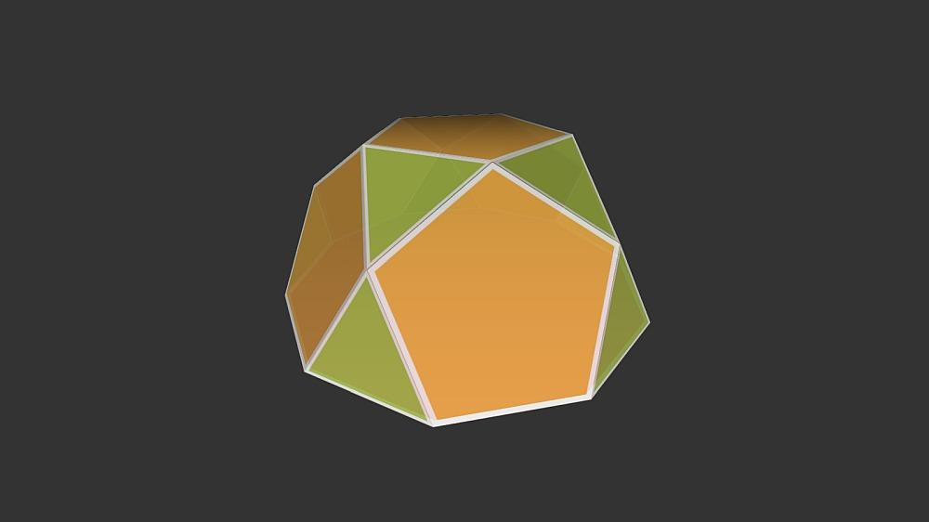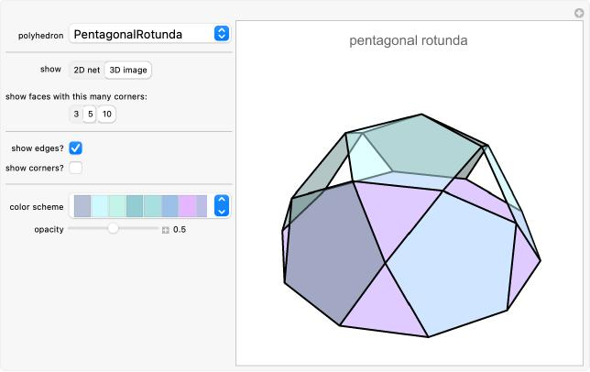

Definition
# Source: AI Source: Provided by: [Data Path: Persons Table -> ID Column: 1, Name_En Column: Motasem Essam] -> From: [ChatGPT] on [7/25/2026]
A Rotunda is a type of polyhedron characterized by a cyclic arrangement of triangular and pentagonal lateral faces around a central axis.
It is similar to a Cupola, but differs in its lateral face arrangement:
- A Cupola alternates between triangular and square faces.
- A Rotunda alternates between triangular and pentagonal faces.
The Pentagonal Rotunda is the principal classical example and is classified as the sixth Johnson solid (J6). <Cite refs={["turn121514search2","turn121514search1","turn121514search0"]}/>

Geometric Structure
# Source: AI Source: Provided by: [Data Path: Persons Table -> ID Column: 1, Name_En Column: Motasem Essam] -> From: [ChatGPT] on [7/25/2026]
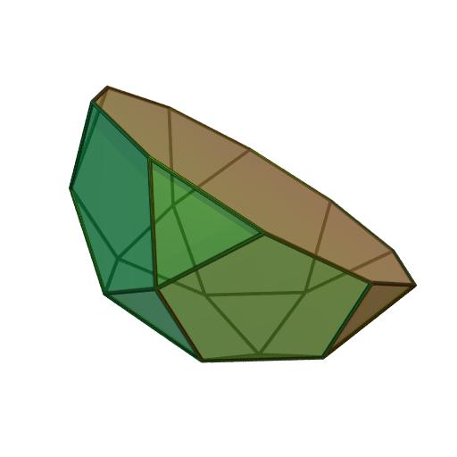
A generalized $n$-gonal Rotunda consists of:
- Upper Base: An $n$-sided polygon.
- Lower Base: A $2n$-sided polygon, rotated relative to the upper base.
- Triangular Faces: $2n$ triangular lateral faces.
- Pentagonal Faces: $n$ pentagonal lateral faces.
- Alternating Arrangement: Triangular and pentagonal faces are arranged alternately around the central axis.
The standard pentagonal rotunda has a pentagonal upper base and a decagonal lower base. <Cite refs={["turn121514search2","turn121514search12"]}/>

Face Composition
# Source: AI Source: Provided by: [Data Path: Persons Table -> ID Column: 1, Name_En Column: Motasem Essam] -> From: [ChatGPT] on [7/25/2026]
For the Pentagonal Rotunda:

Face Type | Number
Triangular Faces | 10
Pentagonal Lateral Faces | 5
Upper Pentagonal Base | 1
Lower Decagonal Base | 1
Total Faces | 17
<Cite refs={["turn121514search1","turn121514search3"]}/>

Mathematical Properties
# Source: AI Source: Provided by: [Data Path: Persons Table -> ID Column: 1, Name_En Column: Motasem Essam] -> From: [ChatGPT] on [7/25/2026]

Property | Value
Total Faces (F) | 17
Total Edges (E) | 35
Total Vertices (V) | 20
Upper Base | Pentagon
Lower Base | Decagon
Johnson Solid Number | J6
Symmetry Group | $$C_{5v}$$
Rotational Symmetry | Order 5
Geometric Type | Convex Polyhedron
<Cite refs={["turn121514search1","turn121514search3"]}/>
General Rotunda Formulas:
For an $n$-gonal Rotunda:
$$F=3n+2, E=7n, V=4n$$
For the Pentagonal Rotunda, $n=5$:
$$F=17, E=35, V=20$$
Euler's Polyhedron Formula:
$$V-E+F=2$$
$$20-35+17=2$$

Geometric Characteristics
# Source: AI Source: Provided by: [Data Path: Persons Table -> ID Column: 1, Name_En Column: Motasem Essam] -> From: [ChatGPT] on [7/25/2026]
- Cyclic Symmetry: Its lateral faces are arranged around a central axis.
- Alternating Lateral Faces: Triangular and pentagonal faces form the lateral structure.
- Two Different Bases: It connects an $n$-gonal upper base to a $2n$-gonal lower base.
- Rotational Symmetry: The standard pentagonal rotunda has fivefold rotational symmetry.
- Cupola Relationship: It resembles a cupola but uses pentagons instead of squares in its lateral face arrangement.
- Johnson Solid: The Pentagonal Rotunda is J6, the only classical rotunda whose faces can all be regular polygons with equal edge lengths. <Cite refs={["turn121514search2","turn121514search1","turn121514search0"]}/>

Types of Rotundas
# Source: AI Source: Provided by: [Data Path: Persons Table -> ID Column: 1, Name_En Column: Motasem Essam] -> From: [ChatGPT] on [7/25/2026]
Rotundas can be classified according to the polygonal arrangement and symmetry of their bases.
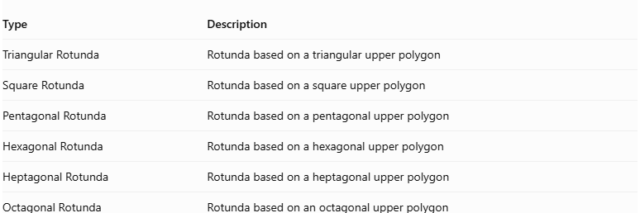
Type | Description
Triangular Rotunda | Rotunda based on a triangular upper polygon
Square Rotunda | Rotunda based on a square upper polygon
Pentagonal Rotunda | Rotunda based on a pentagonal upper polygon
Hexagonal Rotunda | Rotunda based on a hexagonal upper polygon
Heptagonal Rotunda | Rotunda based on a heptagonal upper polygon
Octagonal Rotunda | Rotunda based on an octagonal upper polygon
Star-Rotundas:
- Pentagrammic Rotunda
- Heptagrammic Rotunda
- Enneagrammic Rotunda
- Hendecagrammic Rotunda
These include generalized and star-shaped variants; they should not all be assumed to be convex Johnson solids.

Construction of Rotunda

Geometric Instruments Used
# Source: AI Source: Provided by: [Data Path: Persons Table -> ID Column: 1, Name_En Column: Motasem Essam] -> From: [ChatGPT] on [7/25/2026]
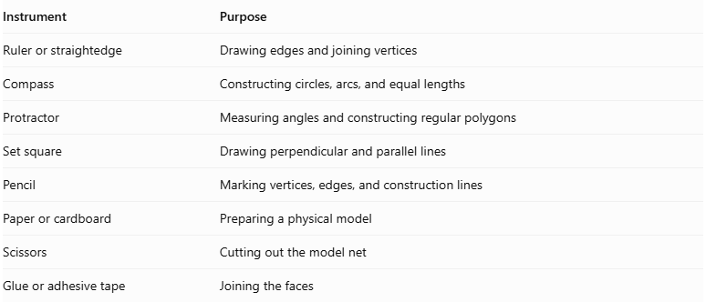
Instrument | Purpose
Ruler or straightedge | Drawing edges and joining vertices
Compass | Constructing circles, arcs, and equal lengths
Protractor | Measuring angles and constructing regular polygons
Set square | Drawing perpendicular and parallel lines
Pencil | Marking vertices, edges, and construction lines
Paper or cardboard | Preparing a physical model
Scissors | Cutting out the model net
Glue or adhesive tape | Joining the faces

Instrument-Based Construction Procedures

Construct the Lower Decagonal Base
# Source: AI Source: Provided by: [Data Path: Persons Table -> ID Column: 1, Name_En Column: Motasem Essam] -> From: [ChatGPT] on [7/25/2026]
- Draw a circle using a compass.
- Divide its circumference into ten equal angular sections.
- Mark the ten vertices using a protractor.
- Connect consecutive vertices using a ruler.
- Complete a regular decagon.
- Check that all ten sides have equal lengths.

Construct the Upper Pentagonal Base
# Source: AI Source: Provided by: [Data Path: Persons Table -> ID Column: 1, Name_En Column: Motasem Essam] -> From: [ChatGPT] on [7/25/2026]
- Draw a second circle above the lower-base construction.
- Divide its circumference into five equal angular sections.
- Mark the five vertices using a protractor.
- Connect consecutive vertices to form a regular pentagon.
- Ensure that the pentagon is smaller than the decagon and has the required dimensions for the standard rotunda.

Construct the Triangular Lateral Faces
# Source: AI Source: Provided by: [Data Path: Persons Table -> ID Column: 1, Name_En Column: Motasem Essam] -> From: [ChatGPT] on [7/25/2026]
- Identify the ten triangular face positions around the decagonal base.
- Mark the vertices that will form the triangular connections between the upper and lower polygonal regions.
- Construct ten equilateral triangular faces.
- Ensure that each triangle shares its edges with the appropriate neighboring faces.
- Check that the triangles follow the alternating face arrangement of the rotunda.

Construct the Pentagonal Lateral Faces
# Source: AI Source: Provided by: [Data Path: Persons Table -> ID Column: 1, Name_En Column: Motasem Essam] -> From: [ChatGPT] on [7/25/2026]
- Identify the five pentagonal face positions around the solid.
- Construct five regular pentagonal faces.
- Connect their vertices to the appropriate vertices of the upper and lower polygonal regions.
- Arrange the pentagons alternately with the triangular faces around the dome.
- Ensure that every shared edge has the same length on both adjoining faces.

Assemble the Rotunda
# Source: AI Source: Provided by: [Data Path: Persons Table -> ID Column: 1, Name_En Column: Motasem Essam] -> From: [ChatGPT] on [7/25/2026]
- Position the regular pentagon at the upper end.
- Position the regular decagon at the lower end.
- Connect the upper and lower polygonal regions through the ten triangles and five pentagons.
- Check that the fivefold rotational arrangement is maintained.
- Ensure that all faces meet edge-to-edge without gaps or unintended overlaps.

Complete the Solid Drawing
# Source: AI Source: Provided by: [Data Path: Persons Table -> ID Column: 1, Name_En Column: Motasem Essam] -> From: [ChatGPT] on [7/25/2026]
- Draw the upper pentagonal base.
- Draw the lower decagonal base.
- Complete all ten triangular lateral faces.
- Complete all five pentagonal lateral faces.
- Use solid lines for visible edges.
- Use dashed lines for hidden edges when necessary.
- Verify the final face, edge, and vertex counts.
Construction restriction: This procedure uses geometric instruments, angle measurements, and geometric relationships. It does not use coordinate-based construction.

Key Points
# Source: AI Source: Provided by: [Data Path: Persons Table -> ID Column: 1, Name_En Column: Motasem Essam] -> From: [ChatGPT] on [7/25/2026]
- Main Example: Pentagonal Rotunda.
- Upper Base: Pentagon.
- Lower Base: Decagon.
- Lateral Faces: 10 Triangles and 5 Pentagons.
- Total Faces: 17.
- Total Edges: 35.
- Total Vertices: 20.
- Rotational Symmetry: Order 5 for the pentagonal example.
- Johnson Solid Number: J6.
- Classification: Convex Polyhedron (Pentagonal Rotunda).

Main Classification
# Source: AI Source: Provided by: [Data Path: Persons Table -> ID Column: 1, Name_En Column: Motasem Essam] -> From: [ChatGPT] on [7/25/2026]
Solid Geometry
└── Types of Solids
└── Rotunda
├── Types of Rotundas
│ ├── Triangular Rotunda
│ ├── Square Rotunda
│ ├── Pentagonal Rotunda
│ ├── Hexagonal Rotunda
│ ├── Heptagonal Rotunda
│ └── Octagonal Rotunda
└── Star-Rotundas
├── Pentagrammic Rotunda
├── Heptagrammic Rotunda
├── Enneagrammic Rotunda
└── Hendecagrammic Rotunda

Conclusion
# Source: AI Source: Provided by: [Data Path: Persons Table -> ID Column: 1, Name_En Column: Motasem Essam] -> From: [ChatGPT] on [7/25/2026]
A Rotunda is a polyhedron with triangular and pentagonal lateral faces arranged around a central axis. Its best-known example, the Pentagonal Rotunda, has a pentagonal upper base, decagonal lower base, 10 triangular faces, and 5 pentagonal lateral faces. It is Johnson solid J6, with 17 faces, 35 edges, and 20 vertices.
Important distinction: The general rotunda family includes geometric and star-shaped variants, but the Pentagonal Rotunda is the classical convex Johnson solid. <Cite refs={["turn121514search1","turn121514search2","turn121514search12"]}/>

